Traditional First Saturday Devotions to the Crowned Madonna

Saturday April 6,2013 at 9AM.
At NYC’s Papally designated Marian Shrine

Our Lady of Mount Carmel
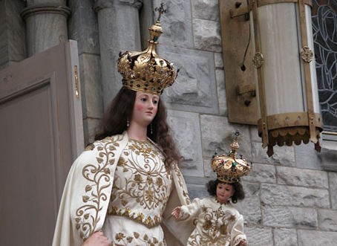
Extraordinary Rite Sung Tridentine Mass
Prayers for the canonization of Pierre Toussaint for the Haitian Community
Mt. Carmel Devotions + Eucharistic Benediction

448 East 116th st. NY, NY 10029
Information 212- 534-0681

Street Parking Available, Enclosed Parking at Costco Complex
M15 limited Bus on First Ave brings you to 116 Street, a block from the church, in minutes
Park

